**Experiment Title.** Write a Python class to find the three elements that sum to zero from a set of n real numbers.

Input array : [-25, -10, -7, -3, 2, 4, 8, 10]

Output : [[-10, 2, 8], [-7, -3, 10]]

**Student Name: Parikshit sharma UID: 19BCS4520**

**Branch: CSE-IOT-1 Section/Group:CSE-IOT-1 A**

**Semester: 4 Date of Performance: 31-03-21**

**Subject Name: PROGRAMMING IN PYTHON LAB Subject Code: CSP=287P**

**1. Overview of Virtual Box:** Write a Python class to find the three elements that sum to zero from a set of n real numbers.

Input array : [-25, -10, -7, -3, 2, 4, 8, 10]

Output : [[-10, 2, 8], [-7, -3, 10]]

**2. Tasks to be done:** To write the source code and run the program in python jupyter notebook .

**3. Steps for practical**: (Mention the steps for each and every task)

1. Firstly create a class name pyth_three and define a function name three_elementsAdd.
2. Now take variables num,res and elements a,b,c.
3. Use the comparision between the elements a,b,c, and compare and perform addition to the elements.
4. And add the result and do append operation and finally after all the comparisions and returning the result give the input given in the question and you will get the output as result.
5. Finally the output comes as per the question.

**4. Screenshots:**

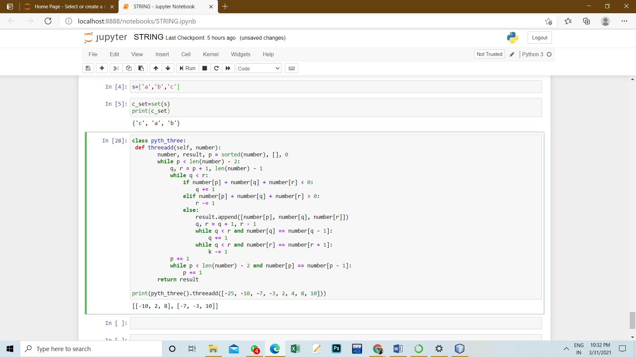

**5. Commands used:**

class pyth_three:

def threeadd(self, number):

number, result, p = sorted(number), [], 0

while p < len(number) - 2:

q, r = p + 1, len(number) - 1

while q < r:

if number[p] + number[q] + number[r] < 0:

q += 1

elif number[p] + number[q] + number[r] > 0:

r -= 1

else:

result.append([number[p], number[q], number[r]])

q, r = q + 1, r - 1

while q < r and number[q] == number[q - 1]:

q += 1

while q < r and number[r] == number[r + 1]:

k -= 1

p += 1

while p < len(number) - 2 and number[p] == number[p - 1]:

p += 1

return result

print(pyth_three().threeadd([-25, -10, -7, -3, 2, 4, 8, 10]))

**6. Result/Output/Writing Summary:**



**Learning outcomes (What I have learnt):**

1. I have learnt how to create a class in python.

2. I have learnt how to define a function.

3.I have learnt how to find the elements and get their elements to zero.

4.I have learnt how to solve the errors .

5.I have learnt how to get output as per the given aim.

**Evaluation Grid (To be created as per the SOP and Assessment guidelines by the faculty):**

|  |  |  |  |
| --- | --- | --- | --- |
| Sr. No. | Parameters | Marks Obtained | Maximum Marks |
| 1. |  |  |  |
| 2. |  |  |  |
| 3. |  |  |  |
|  |  |  |  |